Supplemental Material



Figure 1: Hand motion normal to the indicated plane during the postural and kinetic tasks shown in Figure 2 in the manuscript, recorded from a patient with severe tremor. Tremor is especially visible in each direction in the postural task, and normal to the frontal plane in the kinetic task. Also visible in the kinetic task are the large, voluntary back-and-forth movements of the hand.

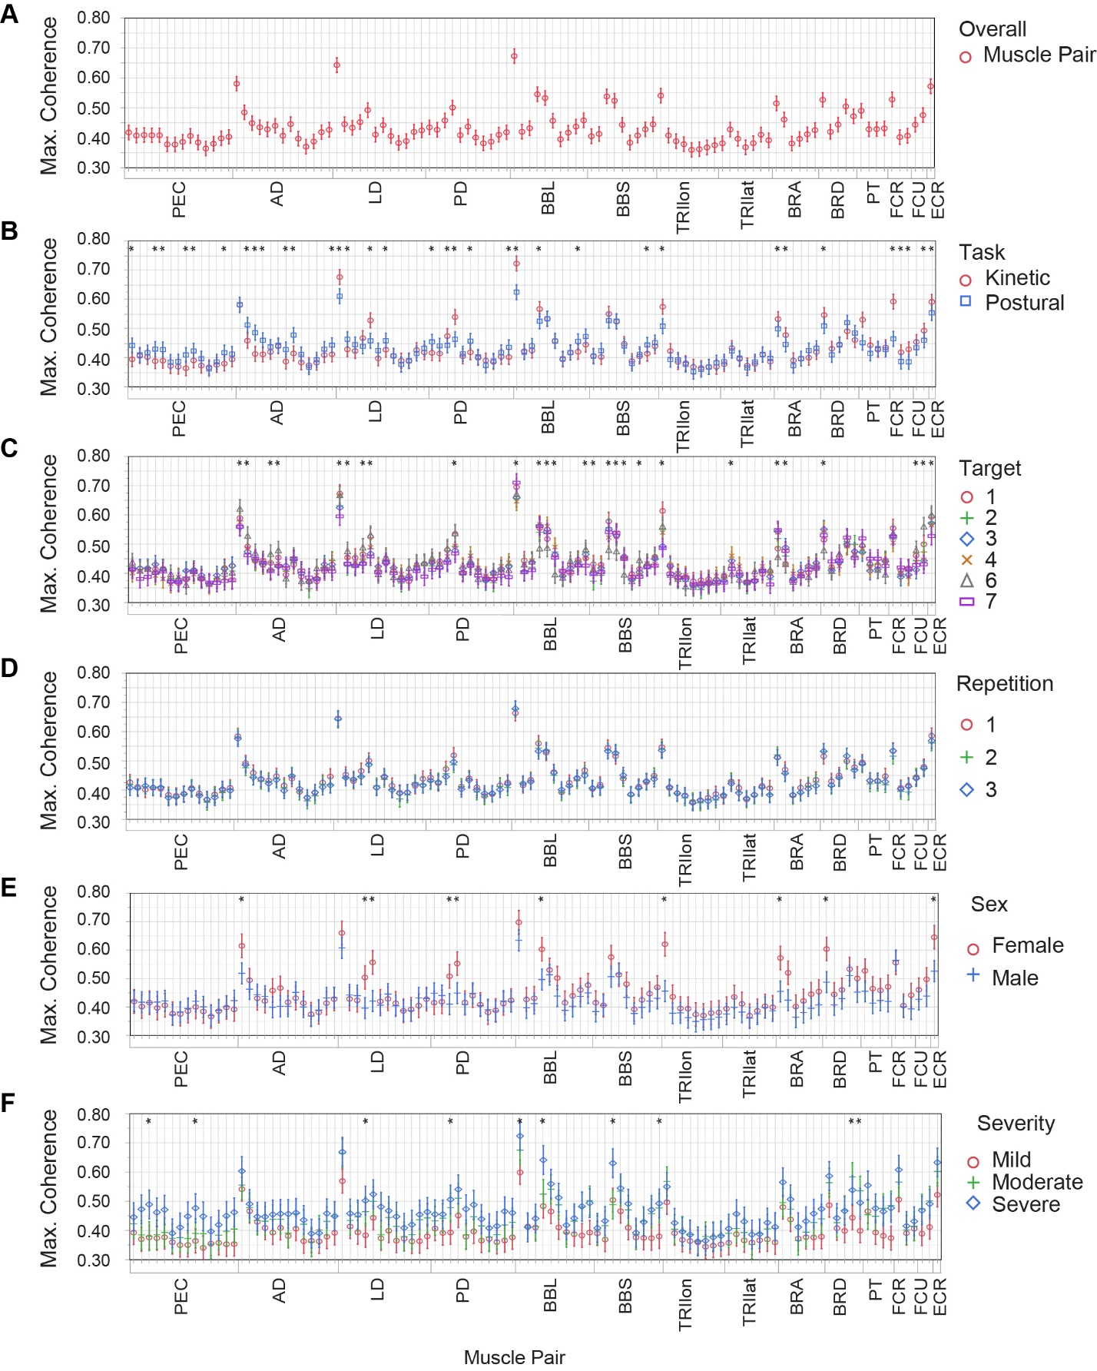

Figure 2: Maximum coherence in the tremor band vs. muscle pair, averaged across all trials (A) or separated by task (B), target (C), repetition (D), sex (E), and severity level (F). Plots of maximum coherence separated by disease duration and age of onset were similar to E and F except with fewer significant differences (not shown). The ordering of muscle pairs is the same for each subplot: muscle pairs are grouped from proximal to distal (all pairs involving PEC, then all pairs involving AD, etc. See caption of Figure 3 in the manuscript for definitions of abbreviations). For example, the first grid line is the PEC with the AD, the second is the PEC with the LD, the last is the ECR with the ECU. Markers and lines indicate mean ± 1 standard error, and asterisks indicate significant differences within a muscle pair.